**PROJECT DESIGN PHASE 2**

**DATA FLOW DIAGRAM AND USER STORIES**

|  |  |
| --- | --- |
| Date | October 2022 |
| Team ID | PNT2022TMID19409 |
| Project name | Smart Waste Management For Metropolitan Cities |
| Maximum marks | 4 marks |

**Dataflow diagrams:**

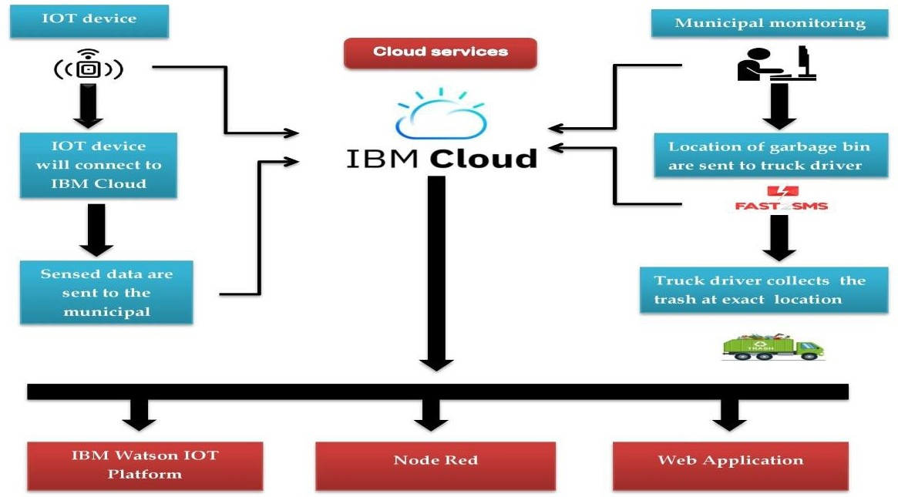The classic visual representation of how information moves through a system is a Data Flow Diagram (DFD). A tidy and understandable DFD can graphically represent the appropriate quantity of the system demand. It demonstrates how information enters and exits the system, what modifies the data, and where information is kept.

**User Stories**

List all the product's user tales using the template below.

|  |  |  |  |  |  |  |
| --- | --- | --- | --- | --- | --- | --- |
| **User Type** | **Functional**  **Requirement**  **(Epic)** | **User Story**  **number** | **User Story/Task** | **Acceptance**  **criteria** | **Priority** | **Release** |
| Customer (Municipal corporation) | Registration | USN-1 | Entering my email, password, and password confirmation allows me to sign up for the application as the Municipal corporation. | I can access my account or dashboard. | High | Sprint-1 |
|  | Data Modules | USN-2 | I shall get the SMS with the sensor values and data as the Municipal corporation. | I can accept messages by clicking "OK." | High | Sprint-1 |
|  | Login | USN-3 | I can access the programme as the Municipal corporation by providing my email and password. | I can log in to my account. | Medium | Sprint-2 |
|  | Dashboard | USN-4 | As the Municipal corporation, I am able to keep an eye on the number of trash cans. | With a unique login name and password, I may access the dashboard. | High | Sprint-2 |
| Customer (Truck Driver) | Registration | USN-1 | I can sign up for the application as a truck driver by providing a valid email address, a password, and a password confirmation | I can log in to my account or dashboard. | High | Sprint-1 |
|  | Data Modules | USN-2 | The municipal will alert me as a truck driver to the location of overflowing trash containers. | I may click "OK" after receiving a notification. | High | Sprint-1 |
|  | Login | USN-3 | I can access the application as a truck driver by providing my email and password. | I can log in to my account. | medium | Sprint-2 |
|  | Dashboard | USN-4 | I can check the progress of my employment as a truck drive. | With a unique login name and password, I may access the dashboard. | High | Sprint-1 |